Instructions for Data Collection

Goals:
- Collect pair/radial distribution function (PDF or RDF) data for molten salts
- Collect experimental thermal conductivity data for molten salts
- Ideally both for each salt

- Record the salt composition, author, and link to paper in the “Data Collection Log”, as well as whether it contains RDF or measurement data.
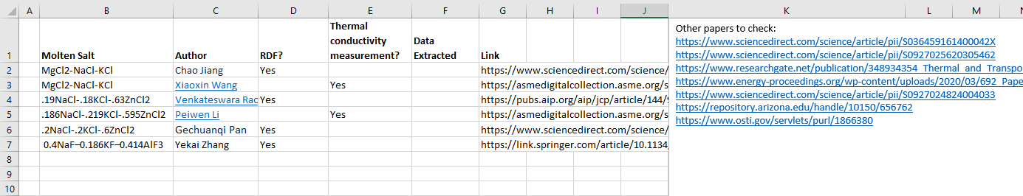
- PDF/RDF Data collection:
  - Choose mixture to analyze. This can be from the list in the excel file “Data Collection Log” or another salt you find that hasn’t already been analyzed (isn’t in the “WebPlotDigitizer – RDFs” folder
  - Use WebPlotDigitizer to collect the data from the RDF plots
    - Take as high resolution image or screenshot of RDF plot as possible
    - Calibrate the plot
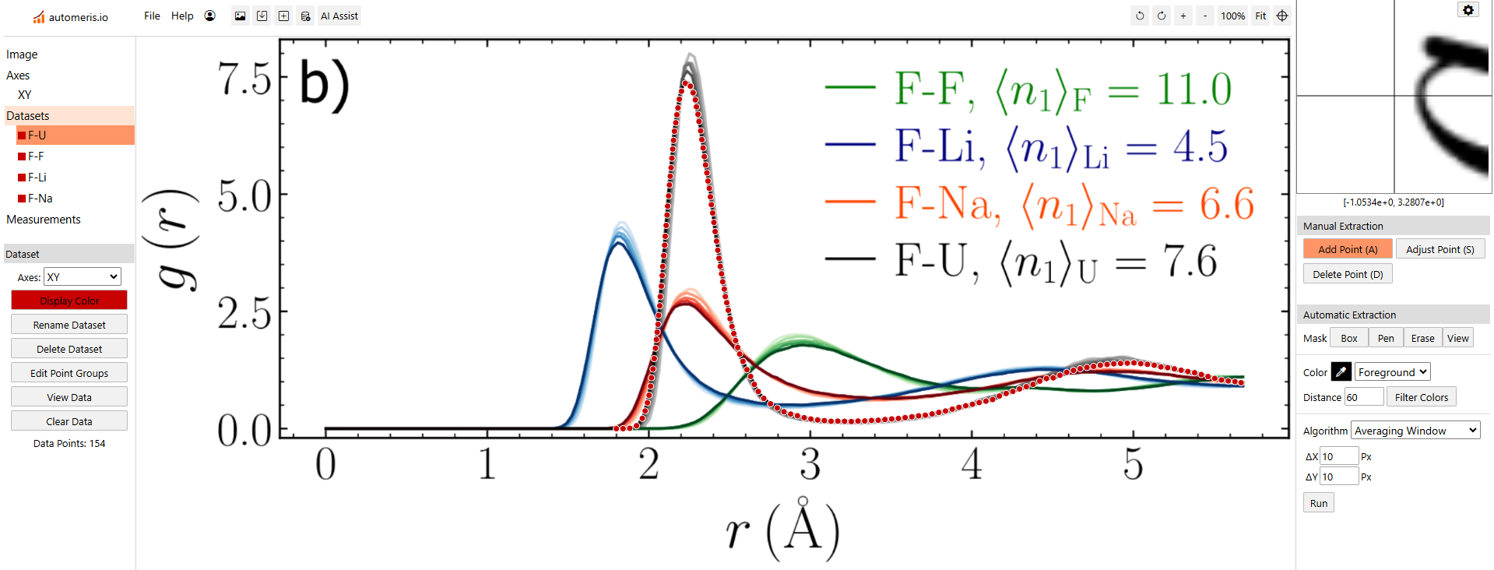
    - Record each ion pair as a separate dataset (if all are featured on one plot). You can use the “Automatic Extraction” and pen to trace most of the line for you (use the dropper to pick the color of the desired line). You will probably have to correct some of the points if the peak is very steep.
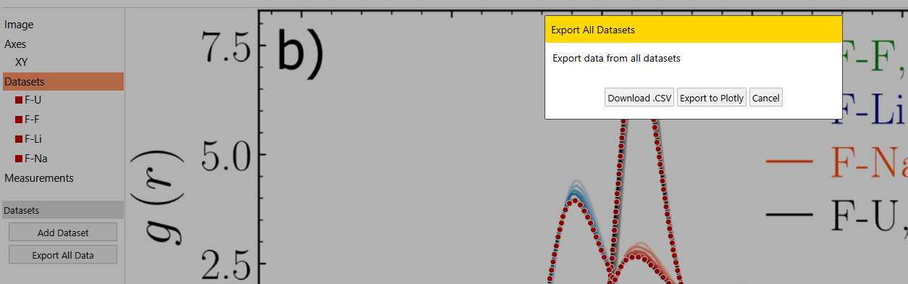
    - After all pairs are plotted, click “Datasets”, then “Export All Data”, then “Download .CSV”. Save to the folder “WebPlotDigitizer – RDFs”.
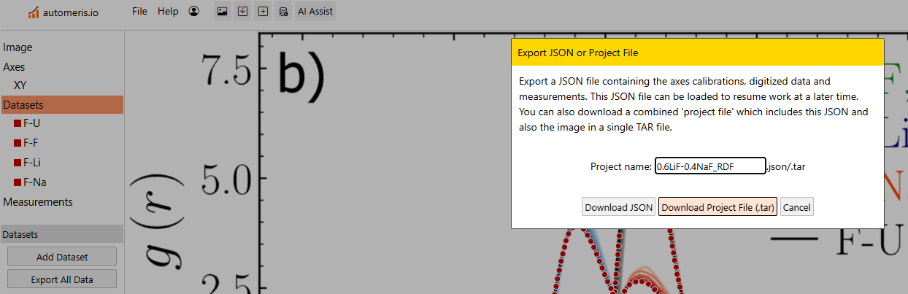
    - Save the project by clicking “File” then “Download Project File (.tar)”. Name the file according the composition (i.e. “0.6LiF-0.4NaF_RDF”

    - It’s important to make sure the datapoints are in the right order on the X-axis; if it looks questionable you can check the CSV file and order each ion pair by the X-axis.

    - Indicate that data has been recorded in the Data Collection Log

- Thermal Conductivity data
  - Use webplotdigitizer to collect the datapoints for thermal conductivity. Make sure the temperature is in Kelving (if it’s in Celsius, you can just add 273.15 when you calibrate the plots).
  - Save the data points in the Data Collection Log excel file under the k_Data tab.
    - Indicate the salt composition, source, formula, and temperature and thermal conductivity data points. You can also indicate “Exp” for experimental data or “MD” for molecular dynamic simulations
